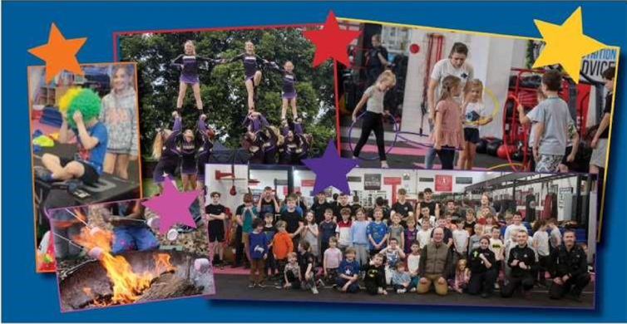

***Tuesday 15th April 2025***

*3Degreez Cheerleading – 14:00-14:45*

*Melody Dance – 15:00- 15:45*

***Both in the HALL***

**Hinton Community Centre , Hereford, HR2 6AF**

**Ages 6-16 years**

***Thursday 24th April 2025***

***Friday 25th April 2025***

*Southwye Police Boxing Academy*

*13:00- 13:45*

***In the Gym***

***Wednesday 16th April 2025***

*Cracked Slipper Company – drama-*

*13:00-13:45*

*Melody Dance – 14:00- 14:45*

***Both in the HALL***

